Parity
# Source: AI Source: Provided by: [Data Path: Persons Table -> ID Column: 1, Name_En Column: Motasem Essam] -> From: [ChatGPT] on [7/13/2026]
Parity is the property of an integer that determines whether it is even or odd. Every integer belongs to exactly one of these two categories, making parity one of the most fundamental concepts in arithmetic and elementary number theory.
Parity is widely used in divisibility, algebra, modular arithmetic, mathematical proofs, cryptography, computer science, and many other branches of mathematics.

Definition
# Source: AI Source: Provided by: [Data Path: Persons Table -> ID Column: 1, Name_En Column: Motasem Essam] -> From: [ChatGPT] on [7/13/2026]
Parity is the classification of an integer according to whether it is divisible by
$$2.$$
An integer has one of two possible parities:
- Even parity: The integer is divisible by
$$2.$$
- Odd parity: The integer is not divisible by
$$2.$$
Mathematically, for an integer
$$n,$$
- Even:
$$n=2k$$
- Odd:
$$n=2k+1$$
where
$$k∈Z.$$

Rules of Parity

1. Every Integer Has Exactly One Parity
# Source: AI Source: Provided by: [Data Path: Persons Table -> ID Column: 1, Name_En Column: Motasem Essam] -> From: [ChatGPT] on [7/13/2026]
Every integer is either even or odd, but never both.
Example
$$14$$
is even.
$$15$$
is odd.

2. Even Numbers Are Divisible by Two
# Source: AI Source: Provided by: [Data Path: Persons Table -> ID Column: 1, Name_En Column: Motasem Essam] -> From: [ChatGPT] on [7/13/2026]
An even integer leaves a remainder of
$$0$$
when divided by
$$2.$$
Example
$$18÷2=9$$

3. Odd Numbers Leave a Remainder of One
# Source: AI Source: Provided by: [Data Path: Persons Table -> ID Column: 1, Name_En Column: Motasem Essam] -> From: [ChatGPT] on [7/13/2026]
An odd integer leaves a remainder of
$$1$$
when divided by
$$2.$$
Example
$$19÷2=9$$
remainder
$$1.$$

4. Zero Is Even
# Source: AI Source: Provided by: [Data Path: Persons Table -> ID Column: 1, Name_En Column: Motasem Essam] -> From: [ChatGPT] on [7/13/2026]
Since
$$0=2×0,$$
zero has even parity.
Example
$$0$$
is an even integer.

5. Negative Integers Also Have Parity
# Source: AI Source: Provided by: [Data Path: Persons Table -> ID Column: 1, Name_En Column: Motasem Essam] -> From: [ChatGPT] on [7/13/2026]
Parity applies to all integers, including negative numbers.
Example
$$-8$$
is even.
$$-11$$
is odd.

6. Consecutive Integers Have Opposite Parity
# Source: AI Source: Provided by: [Data Path: Persons Table -> ID Column: 1, Name_En Column: Motasem Essam] -> From: [ChatGPT] on [7/13/2026]
If one integer is even, the next consecutive integer is odd.
Example
$$24$$
is even.
$$25$$
is odd.

7. Every Integer Can Be Written in Exactly One Standard Form
# Source: AI Source: Provided by: [Data Path: Persons Table -> ID Column: 1, Name_En Column: Motasem Essam] -> From: [ChatGPT] on [7/13/2026]
Every integer is uniquely expressible as either
$$2k$$
or
$$2k+1.$$

Examples
# Source: AI Source: Provided by: [Data Path: Persons Table -> ID Column: 1, Name_En Column: Motasem Essam] -> From: [ChatGPT] on [7/13/2026]
Example 1
Determine the parity of
$$8.$$
Since
$$8=2×4,$$
it is even.

Example 2
Determine the parity of
$$27.$$
Since
$$27=2×13+1,$$
it is odd.

Example 3
Determine the parity of
$$0.$$
Since
$$0=2×0,$$
it is even.

Example 4
Determine the parity of
$$-15.$$
Since
$$-15=2×(-8)+1,$$
it is odd.

Example 5
Determine the parity of
$$102.$$
Since
$$102=2×51,$$
it is even.

Example 6
Determine the parity of
$$999.$$
Since
$$999=2×499+1,$$
it is odd.

Parity Arithmetic Rules
# Source: AI Source: Provided by: [Data Path: Persons Table -> ID Column: 1, Name_En Column: Motasem Essam] -> From: [ChatGPT] on [7/13/2026]
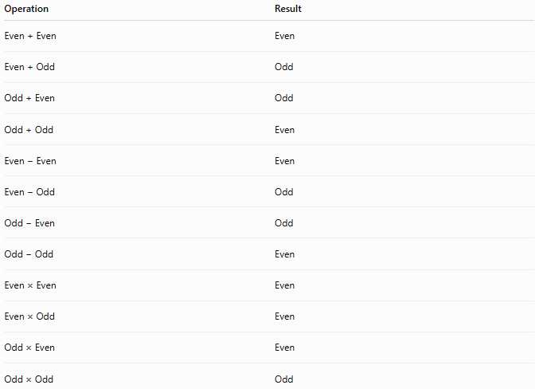
Operation | Result
Even + Even | Even
Even + Odd | Odd
Odd + Even | Odd
Odd + Odd | Even
Even − Even | Even
Even − Odd | Odd
Odd − Even | Odd
Odd − Odd | Even
Even × Even | Even
Even × Odd | Even
Odd × Even | Even
Odd × Odd | Odd

Determining Parity
# Source: AI Source: Provided by: [Data Path: Persons Table -> ID Column: 1, Name_En Column: Motasem Essam] -> From: [ChatGPT] on [7/13/2026]
To determine the parity of an integer:
- Divide the integer by
$$2.$$
- If the remainder is
$$0,$$
the number is even.
- If the remainder is
$$1$$
or
$$-1,$$
the number is odd.

Real-Life Applications
# Source: AI Source: Provided by: [Data Path: Persons Table -> ID Column: 1, Name_En Column: Motasem Essam] -> From: [ChatGPT] on [7/13/2026]
Parity is used in:
- Computer science
- Error detection
- Cryptography
- Digital communication
- Algorithm design
- Mathematical proofs
- Number theory
- Binary arithmetic
- Data storage
- Coding theory

Real-Life Examples
# Source: AI Source: Provided by: [Data Path: Persons Table -> ID Column: 1, Name_En Column: Motasem Essam] -> From: [ChatGPT] on [7/13/2026]
1. Computer Memory
Computers use parity bits to detect transmission and memory errors.

2. Barcode Systems
Some barcode formats use parity patterns to verify data accuracy.

3. Digital Communication
Networks use parity checking to detect corrupted data.

4. Cryptography
Parity is used in certain cryptographic algorithms and error-checking techniques.

5. Mathematical Proofs
Many proofs use parity arguments, such as proving that
$$\sqrt{2}$$
is irrational.

6. Programming
Programs often test whether a number is even or odd before performing computations.

Common Mistakes
# Source: AI Source: Provided by: [Data Path: Persons Table -> ID Column: 1, Name_En Column: Motasem Essam] -> From: [ChatGPT] on [7/13/2026]
- Thinking that zero is odd.
- Forgetting that negative integers have parity.
- Assuming parity applies to fractions or decimals.
- Confusing parity with primality.
- Believing that every odd number is prime.

Key Points
# Source: AI Source: Provided by: [Data Path: Persons Table -> ID Column: 1, Name_En Column: Motasem Essam] -> From: [ChatGPT] on [7/13/2026]
- Every integer has exactly one parity.
- An even number has the form
$$2k.$$
- An odd number has the form
$$2k+1.$$
- Zero is even.
- Consecutive integers always have opposite parity.
- Parity is fundamental in arithmetic and elementary number theory.

Even vs. Odd Numbers
# Source: AI Source: Provided by: [Data Path: Persons Table -> ID Column: 1, Name_En Column: Motasem Essam] -> From: [ChatGPT] on [7/13/2026]
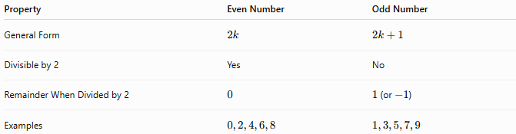
Property | Even Number | Odd Number
General Form | $$2k$$ | $$2k+1$$
Divisible by 2 | Yes | No
Remainder When Divided by 2 | $$0$$ | $1$(or $-1$)
Examples | $$0,2,4,6,8$$ | $$1,3,5,7,9$$

Conclusion
# Source: AI Source: Provided by: [Data Path: Persons Table -> ID Column: 1, Name_En Column: Motasem Essam] -> From: [ChatGPT] on [7/13/2026]
Parity is the property that classifies every integer as even or odd according to its divisibility by 2. Every integer has exactly one parity, making parity one of the most fundamental concepts in arithmetic and elementary number theory. It plays a central role in divisibility, modular arithmetic, mathematical proofs, computer science, cryptography, digital communication, and many other mathematical and computational

